**Association Rules Mining in R - Getting the Packages**

**(HOW TO - Dr. Ami Gates, 4/26/18)** The following will take you through the steps to get arules and arulesViz to work properly on R version 3.5.x.

1) To get and install **RTools**

Step 1 – go to : <http://cran.r-project.org/bin/windows/Rtools/>

Step 2 – choose RTools35.exe and save to your computer where you can get at it.

Step 3 – double click to install.

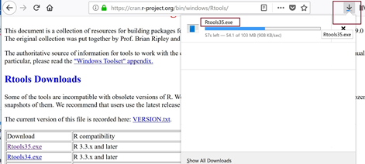

Step 4 – follow all the steps. The location for the install us up to you. I allowed the default of:

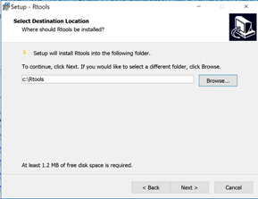

Make sure to add it to your PATH

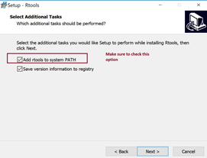

All of the other default options are fine.

Continue with and complete the installation.

2) Next, in RStudio, use install.packages to install **all of the following:**

install.packages("arules")

install.packages("TSP")

install.packages("data.table")

install.packages("sp")

install.packages("dplyr", dependencies = TRUE)

install.packages("purrr", dependencies = TRUE)

install.packages("devtools", dependencies = TRUE)

install.packages("tidyr")

install.packages("viridis")

For any of the above, if you are asked if you want to INSTALL FROM SOURCE - **click YES!**

**In your R code, you will have all of these libraries.**

library(viridis)

library(arules)

library(TSP)

library(data.table)

library(tcltk)

library(dplyr)

library(devtools)

library(purrr)

library(tidyr)

UPDATE 4/29/18: DrGates -

I am now (suddenly) getting a new error in my Association Rule Mining. Changing to version 3.5.0 has changed many dependencies.

While I code worked perfectly yesterday, today, I get the following errors:

Error in length(x) : Method length not implemented for class rules

Error in length(obj) : Method length not implemented for class rules

detach("package:arules", unload=TRUE)  
library("arules", lib.loc="[wherever your R libraries go]")

To find your lib path

> .libPaths()

Mine are here: "C:/Users/profa/Documents/R/win-library/3.4", "C:/Program Files/R/R-3.5.0/library"

I had to resort back to my C:/Users/profa/Documents/R/win-library/3.4 to get my code to work again.

My guess is that the update to 3.5.0 is not working well with all libraries yet.

NOTE: My code now works for arules and arulesViz - so hopefully these solutions will work for everyone.

3) Finally, you will need to go through a few steps to **get arulesViz to work on R version 3.5.0.**

You will need to install arulesViz from github.

1) Register and get a github account and log into github. (githib.com)

2) Next, go to : <https://github.com/mhahsler/arulesViz>

3) Next, do this in your R code.

library("devtools") ## you may have to install devtools

!!! You must be logged in to github for this to work !!!

Go to <https://github.com/mhahsler/arulesViz> and sign in.

install_github("mhahsler/arulesViz") ## this is done only one.

You may get errors that tell you that you are missing packages. If you are, install then, add the library() for that package and then run everything again.

**TUTORIALS FOR ASSOCIATION RULES**

(and the data)

<https://drive.google.com/drive/folders/1QdLLYoVj-eLK1f_9KA0VxvtwAgWca9Lj?usp=sharing>